**Half and Full Wave Rectifier**

**lab No#04**



**Spring 2021**

**CSE-206L Electronic Circuits Lab**

Submitted by: **Ashfaq Ahmad**

Registration No: **19PWCSE1795**

Class Section: **B**

“On my honor, as student of University of Engineering and Technology, I have neither given nor received unauthorized assistance on this academic work.”

Student Signature: ______________

Submitted to:

**Eng: Abdullah Hameed**

May 31, 2021

**Department of Computer Systems Engineering**

**University of Engineering and Technology, Peshawar**

**Objectives:**

To become familiar with Full wave and half wave rectification.

**Equipment:**

Oscilloscope

Function Generator

**Components**

Diodes: Silicon (D1N4007)

Resistor: 2 kΩ,

**Note: we will use** Silicon (D1N4007) because it don’t break quickly as compare to Silicon (D1N4002).

**Theory:**

**Diode:**

A diode is a two-terminal electronic component that conducts current primarily in one direction; it has low resistance in one direction, and high resistance in the other.

A widely used application of this feature and diodes in general is in the conversion of an alternating voltage (AC) into a continuous voltage (DC). In other words, *Rectification*.

Power diodes can be used individually as above or connected together to produce a variety of rectifier circuits such as “Half-Wave”, “Full-Wave” or as “Bridge Rectifiers”.

**Half Wave Rectification**

Half-wave rectifiers transform AC voltage to DC voltage. A half wave rectifier circuit uses only one diode for the transformation.

A half wave rectifier is defined as a type of rectifier that allows only one-half cycle of an AC voltage waveform to pass while blocking the other half cycle.

**Function:**

During the positive half cycle of the AC voltage, the diode will be forward biased and the current flows through the diode. During the negative half cycle of the AC voltage, the diode will be reverse biased and the flow of current will be blocked. The final output voltage waveform on the secondary side (DC) is shown in figure 3 above. ***As polarity continuously changing of AC source that’s why in positive half it become forward bias while in negative half it become reverse bias while in reverse bias there is resistance mean no current flow.***

If we connect diode in reverse biased the procedure will be reciprocal mean negative half will conduct while positive half will be zero.

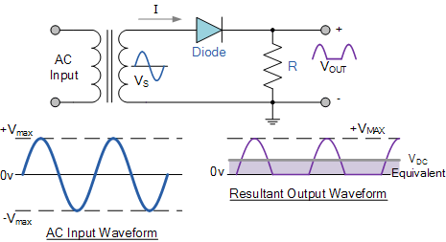

* For better understanding, let us consider half wave rectifier circuit as shown below:

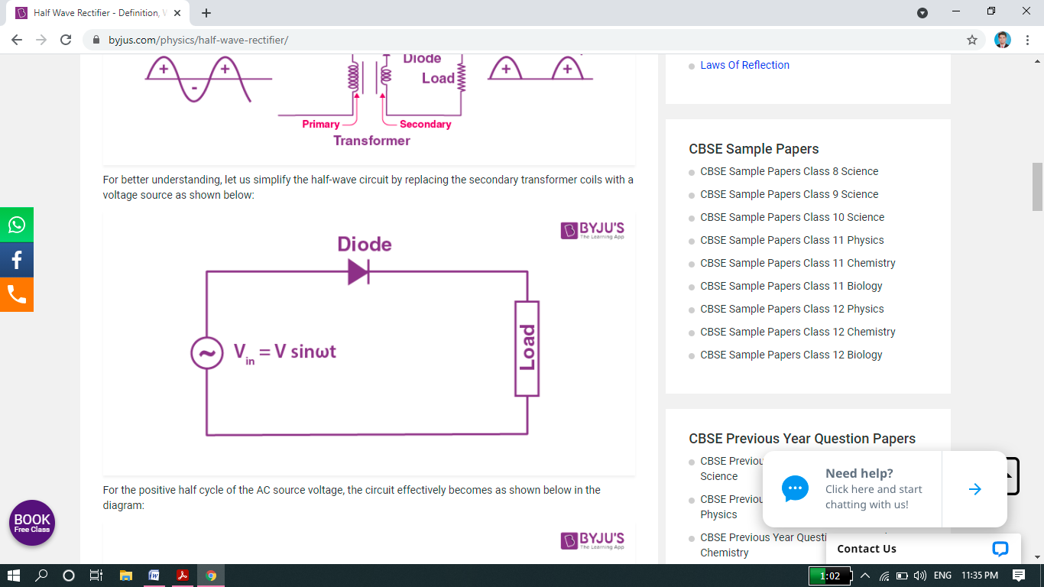

* For the positive half cycle of the AC source voltage, the circuit effectively becomes as shown below in the diagram:

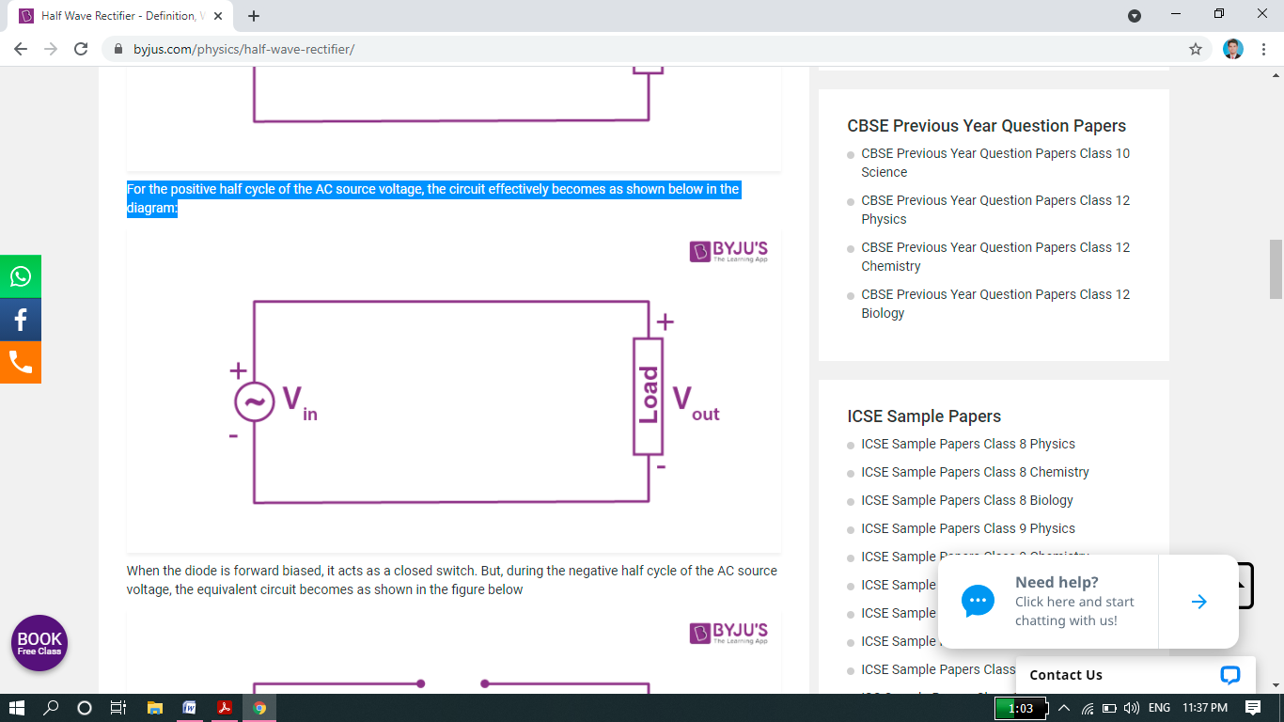

* When the diode is forward biased, it acts as a closed switch. But, during the negative half cycle of the AC source voltage, the equivalent circuit becomes as shown in the figure below

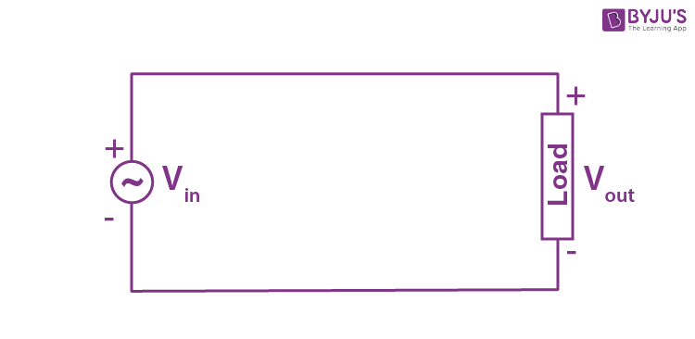

* When the diode is forward biased, it acts as a closed switch. But, during the negative half cycle of the AC source voltage, the equivalent circuit becomes as shown in the figure below

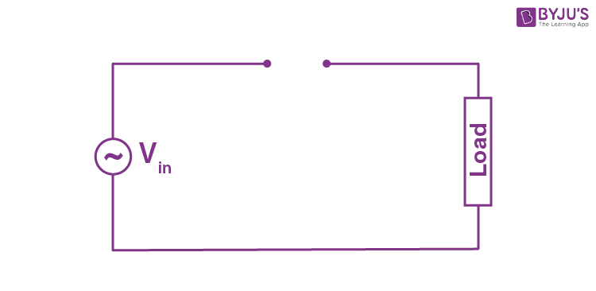

### Half Wave Rectifier Waveform:

* The half wave rectifier waveform before and after rectification is shown below in the figure.

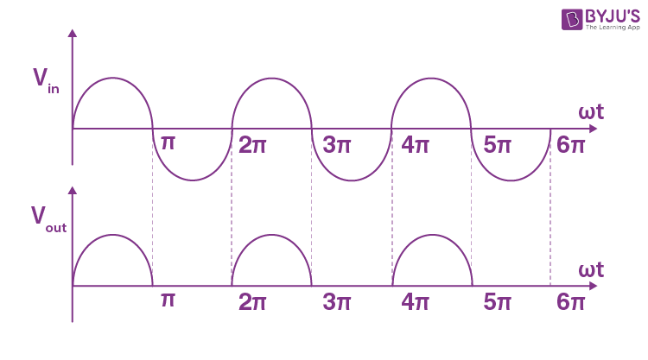

**Proteus schematic of Half wave Rectifier:**

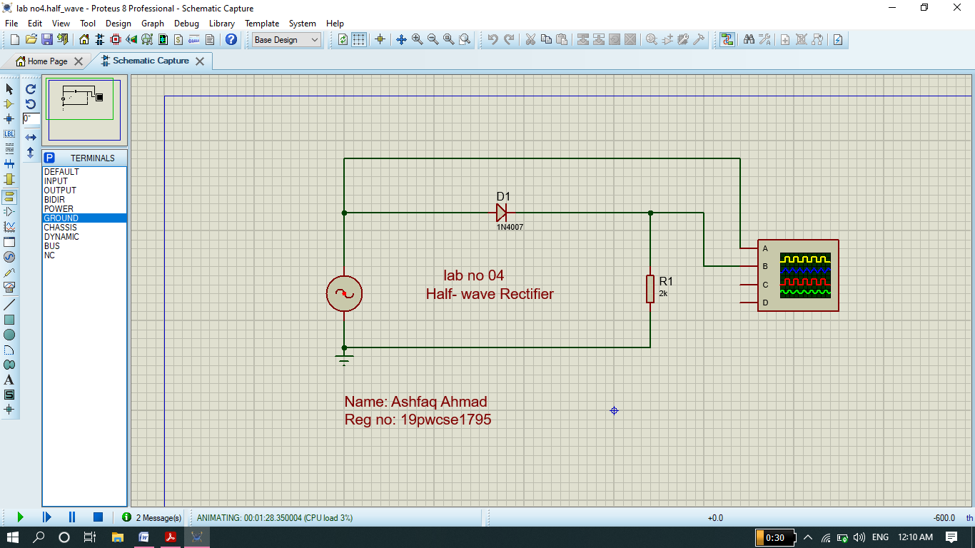

**Graph( yellow=input signal, blue=output signal)**

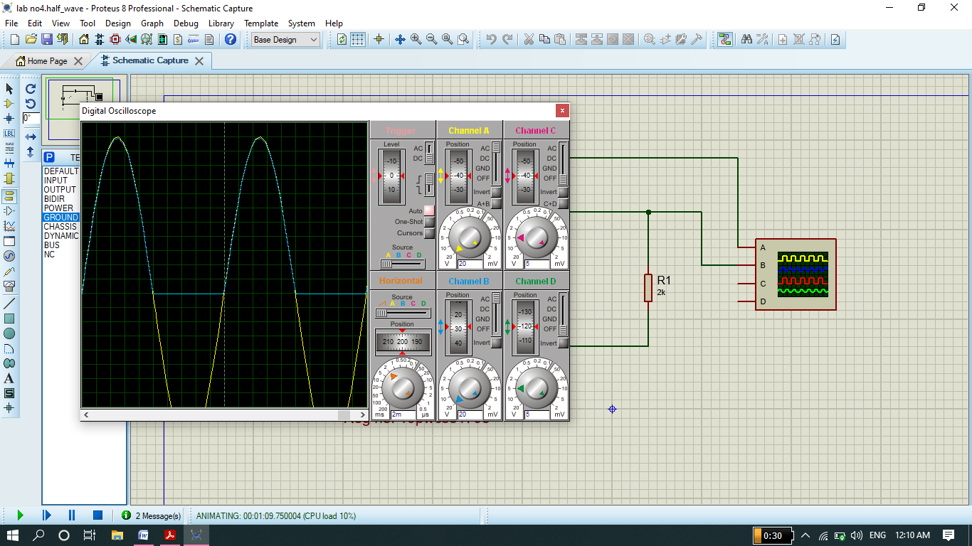

**PCB layout:**

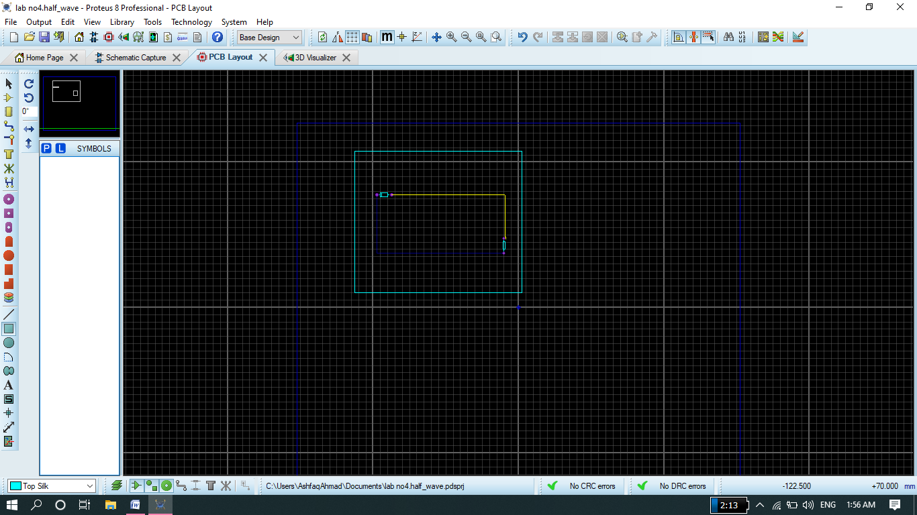

**3D viewer:**

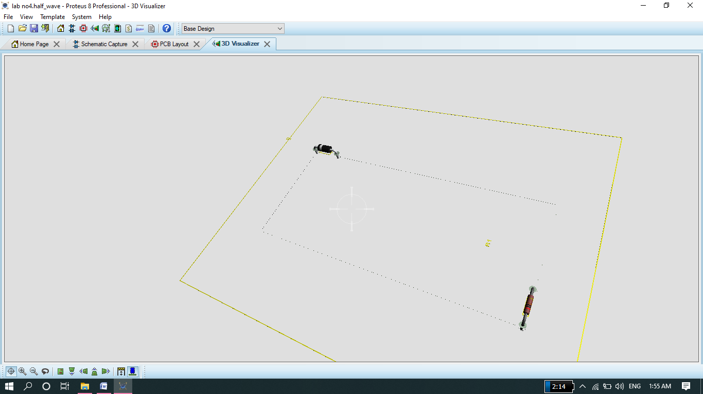

**Full wave Rectifier**

A **full wave rectifier** is defined as a **rectifier** that converts the complete cycle of alternating current into pulsating DC. Unlike half wave rectifiers that utilize only the half wave of the input AC cycle, **full wave** rectifiers utilize the **full** cycle.

We can also define as A Full wave rectifier is a circuit arrangement which makes use of both half cycles of input alternating current (AC) and converts them to direct current (DC).

#### During the first half cycle

As Ac Source changing their polarity continuously so During the first half cycle of the input voltage, the upper end of the transformer secondary winding is positive with respect to the lower end. Thus during the first half cycle diodes D1 and D3 are forward biased and current flows through arm D1, enters the load resistance RL, and returns back flowing through D3. During this half of each input cycle, the diodes D2 and D4are reverse biased and current is not allowed to flow in D2 and D4. The flow of current is indicated by solid arrows in the figure above. We have developed another diagram below to help you understand the current flow quickly. See the diagram below – the green arrows indicate the beginning of current flow from the source (transformer secondary) to the load resistance. The red arrows indicate the return path of current from load resistance to the source, thus completing the circuit.

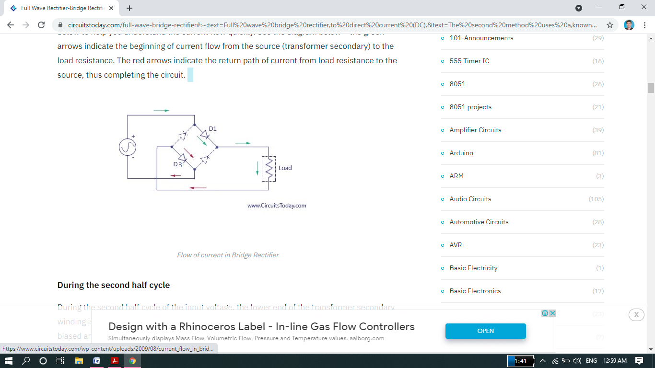

#### During the second half cycle

During the second half cycle of the input voltage, the lower end of the transformer secondary winding is positive with respect to the upper end. Thus diodes D2 and D4 become forward biased and current flows through D2, enters the load resistance RL,  and returns back to the source flowing through D4. The flow of current has been shown by dotted arrows in the figure. Thus the direction of flow of current through the load resistance RL remains the same during both half cycles of the input supply voltage.  See the diagram below – the green arrows indicate the beginning of current flow from the source (transformer secondary) to the load resistance. The red arrows indicate the return path of current from load resistance to the source, thus completing the circuit.

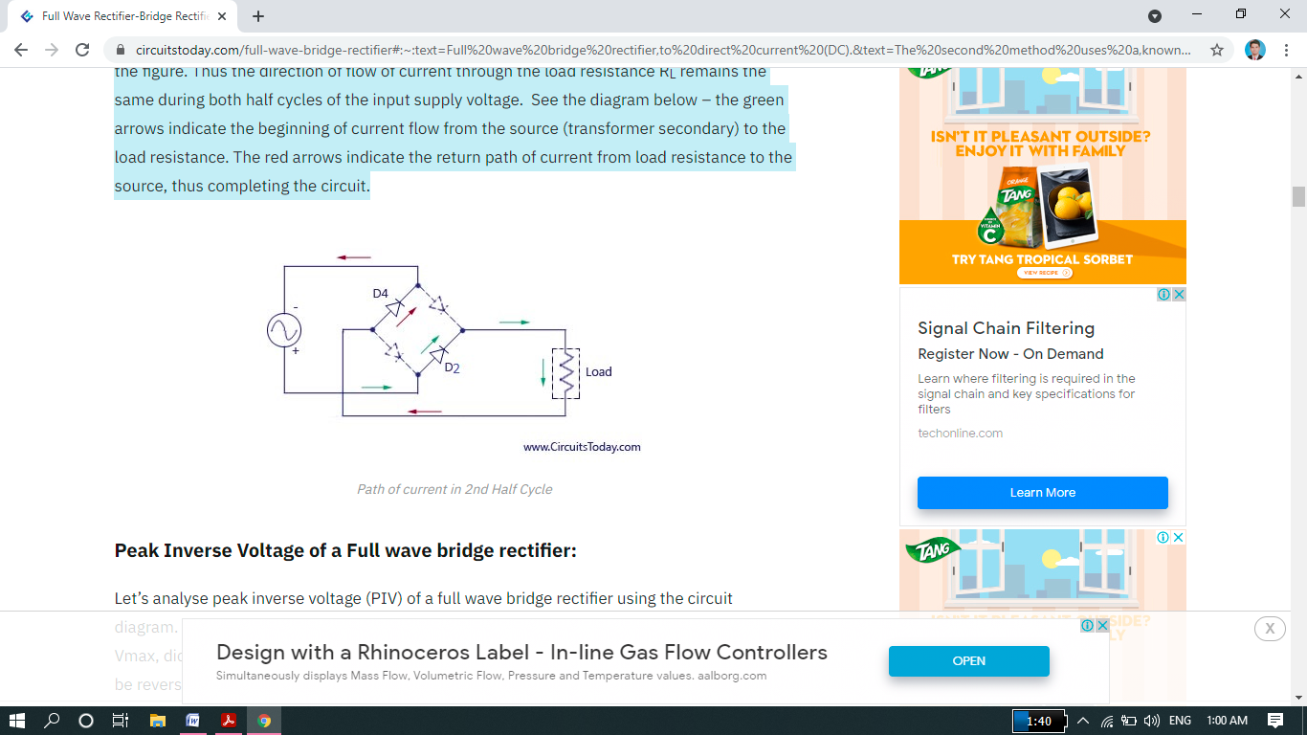

**Proteus Schematic of Full Wave Rectifier:**

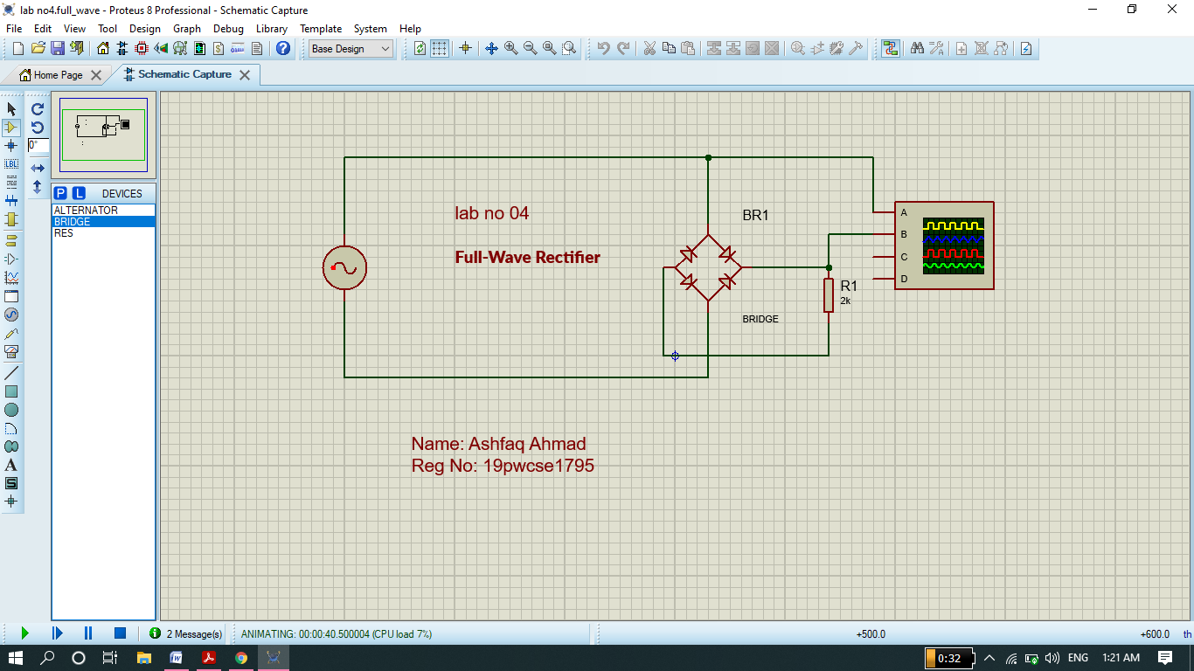

**Graph (yellow line=input signal, blue line=output signal)**

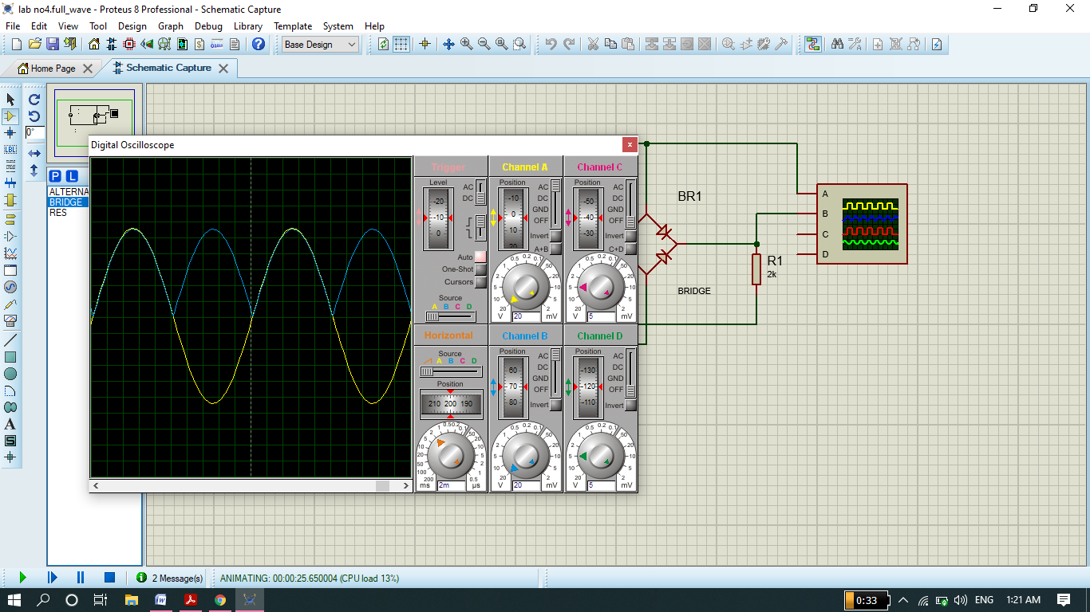

**PCB layout:**

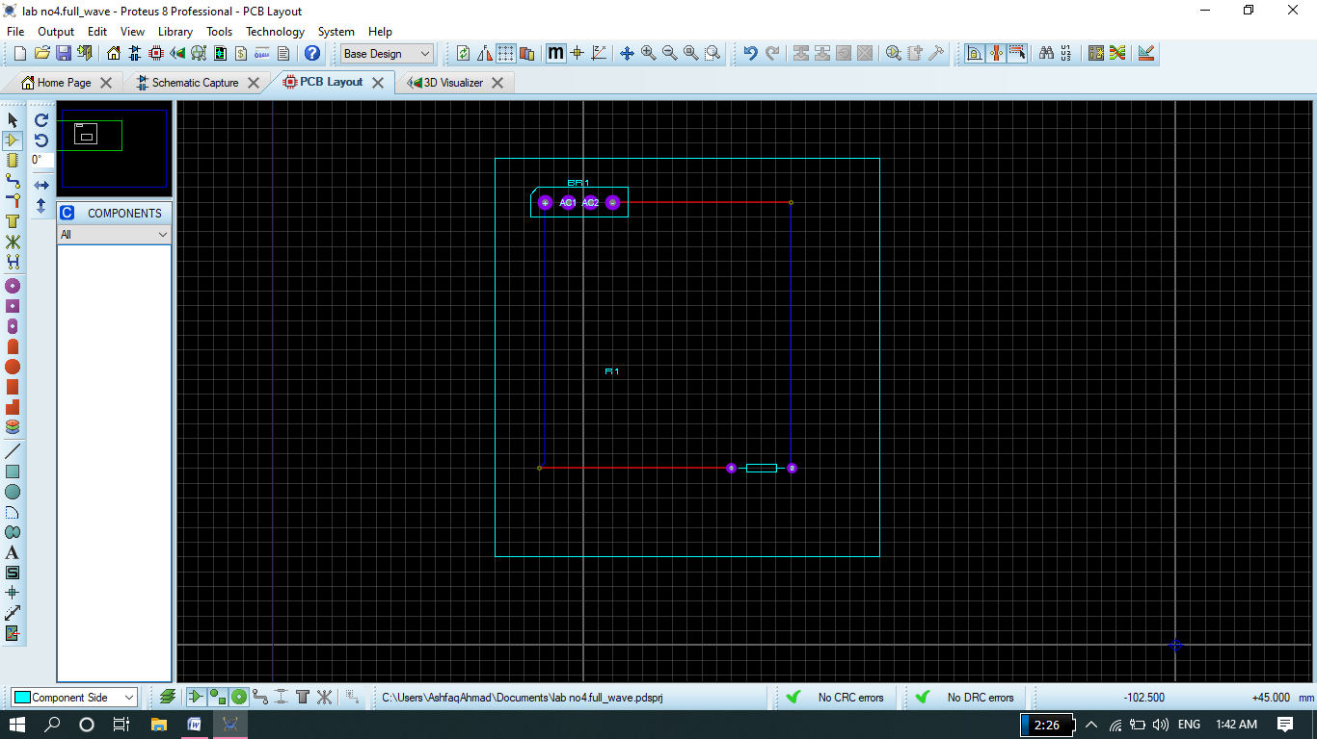

**3D view:**

